The profile page is definitely important, for it provides users with access to reviewing and changing their personal information.

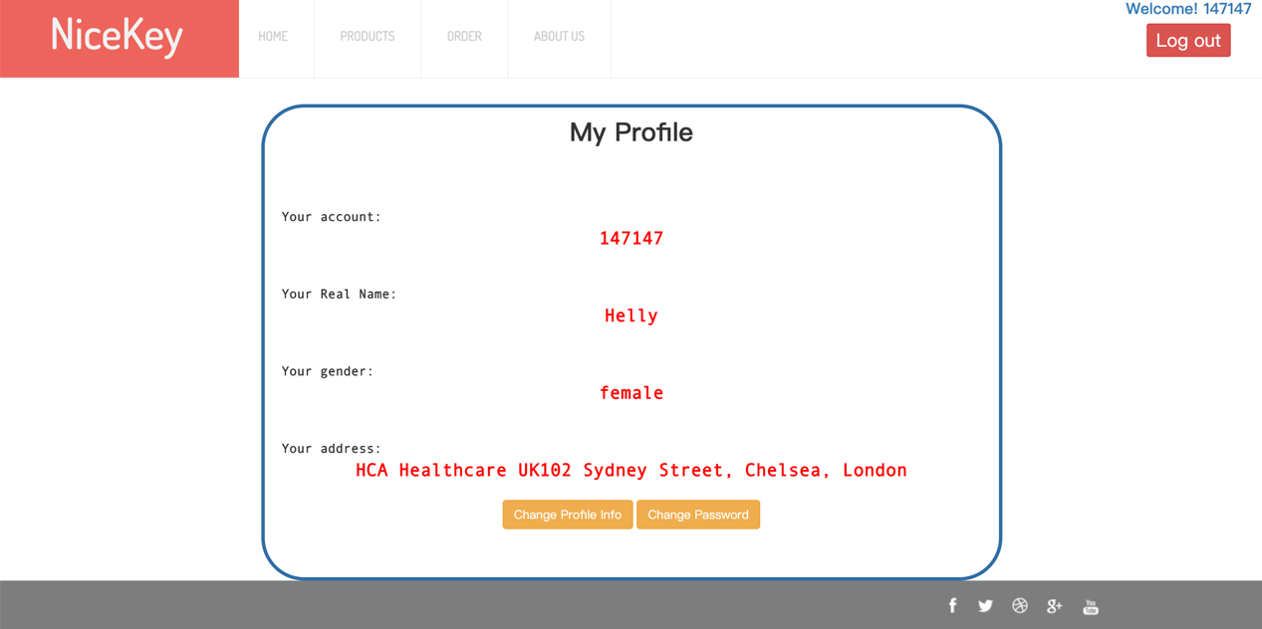

Highlighted in red bold font, information could be clearly read. Two eye-catching buttons provide functions of changing info or password.

A verification would take place for security purpose when you try to change your information. Click into “Change Profile Info”, the window first prompt the user to enter the password to verify.

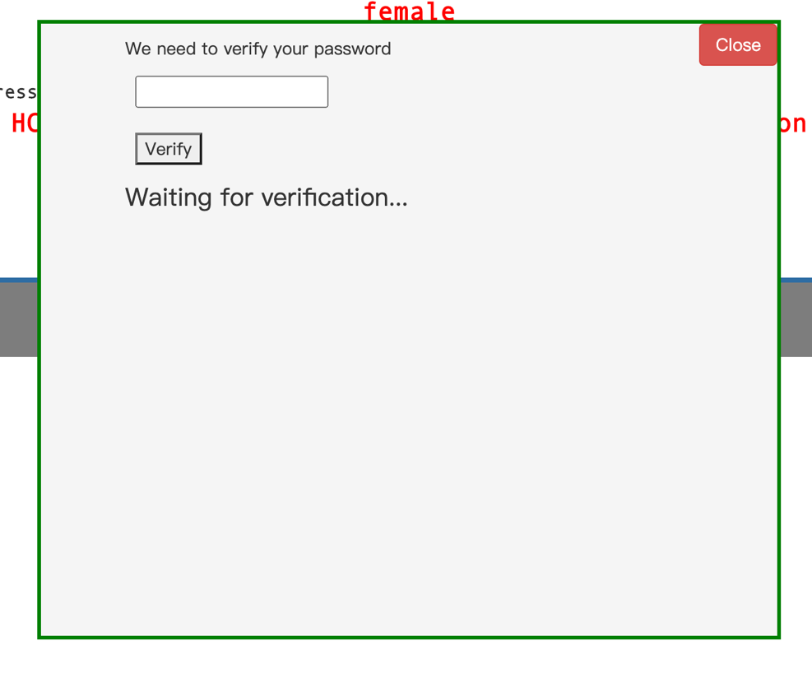

When verification is done, two input box would pop up. Fill in the blanks and click, then the change is done.

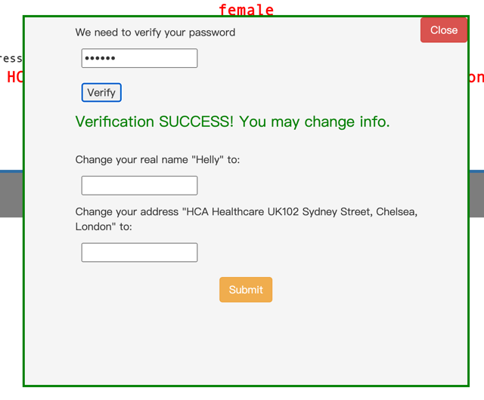

Order Page

The Order page is where users can review their orders in detail, including Order ID, products information, current status total price, order time and so forth. Neatly as the information is presented, there are a couple of great mechanisms behind the page presentation.

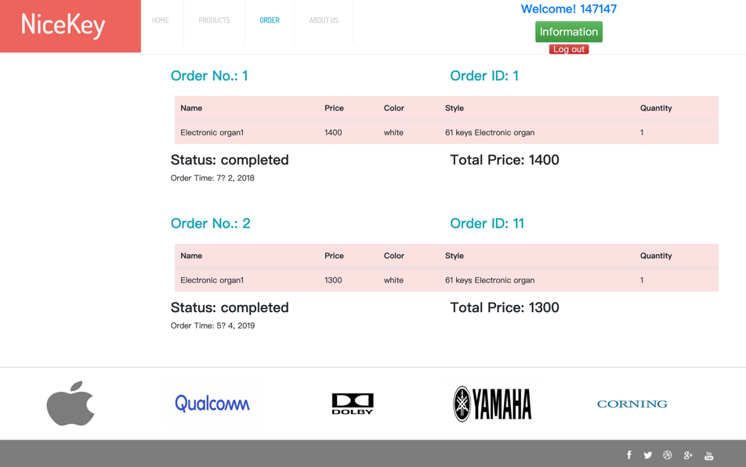

First of all, we thought of an elegant and efficient way to present the orders, which is to use “Vue.js”. As a progressive Javascript framework, vue has brought front-end development great convenience. A simple declaration of variables and iterations helps you build a neat and cohesive presentation.

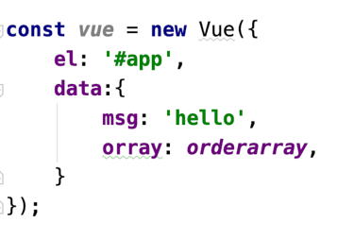

So now comes another problem, which is to pass the arraylist to Javascript (arraylist in Java cannot be directly retrieved by Javascript, which are two different languages. So finally JSON (Javascript Object Notation) comes to our help.

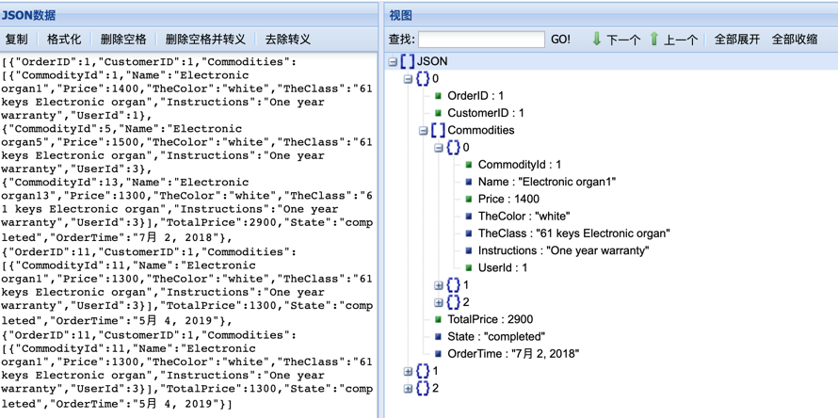

By using the JSON string as a media, the information can be appropriately passed to Javascript, which can be further presented on the webpage.